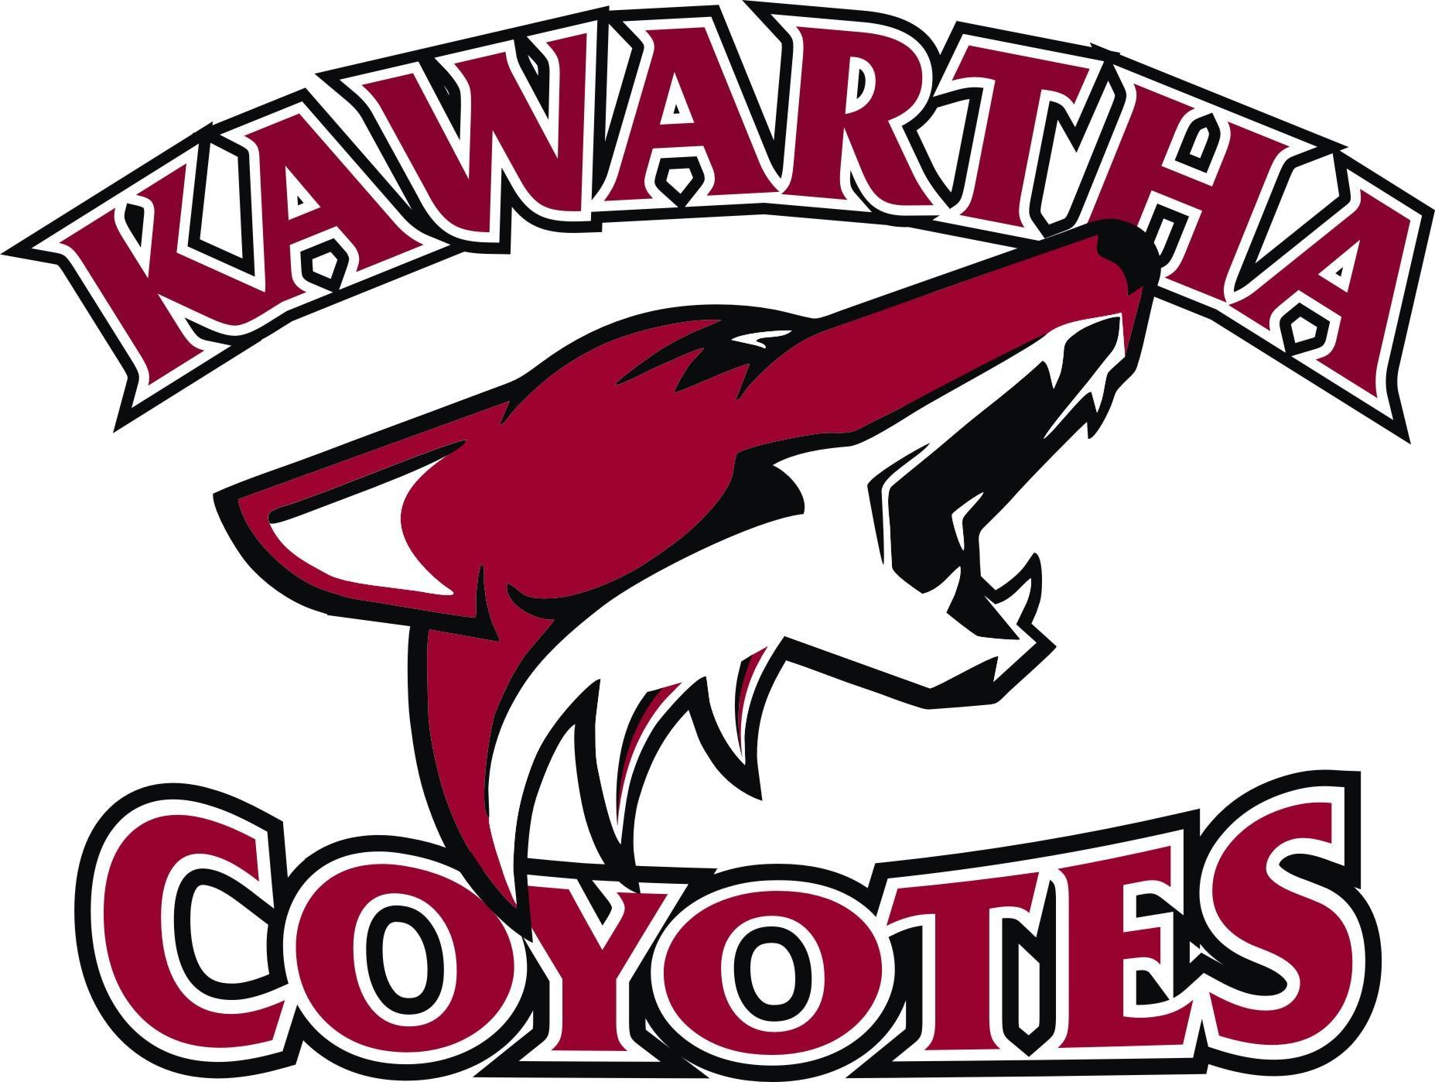

NOTICE OF “PROPOSED” CONSTITUTION AMENDMENTS
Please be advised of the proposed amendment to the current Constitution of Kawartha Minor Hockey Association.

Constitution Article:

Current wording:

Proposed wording:

Rationale for change:

Submitted by:

For consideration at the Annual General Meeting of Kawartha Minor Hockey Association, please forward this form to KMHA secretary in care of KMHA.Secretary@gmail.com at least fourteen (14) days prior to the date of the Annual General Meeting as posted on the KMHA website.

